Cooking Demonstration
March 2, 2023
Presenter: Chef Marisa Peña from Bread Line, Inc.

Topics: How to cook frozen fruits and vegetables
How to cook dry or canned beans

How to cook frozen fruits and vegetables

IQF - individually quick frozen; each piece of food is frozen individually rather than all together as one icy slab.

Top 5 benefits of using IQF foods:

- A great way to preserve food - IQF foods can last up to 6 months as long as it is stored properly
- Frozen foods can be more nutritious - IQF foods maintain their freshness and so retain all of their nutrients; tend to have no added salt or preservatives
- IQF foods are cheaper - food waste is reduced; makes fresh food more readily available
- Frozen fruits and vegetables are always in season - IQF foods are often frozen at the peak of their season so access to fresh, seasonal ingredients becomes possible year round.
- Food quality is better maintained - the IQF process ensures that the frozen food stays at its best in terms of freshness and nutritional value.

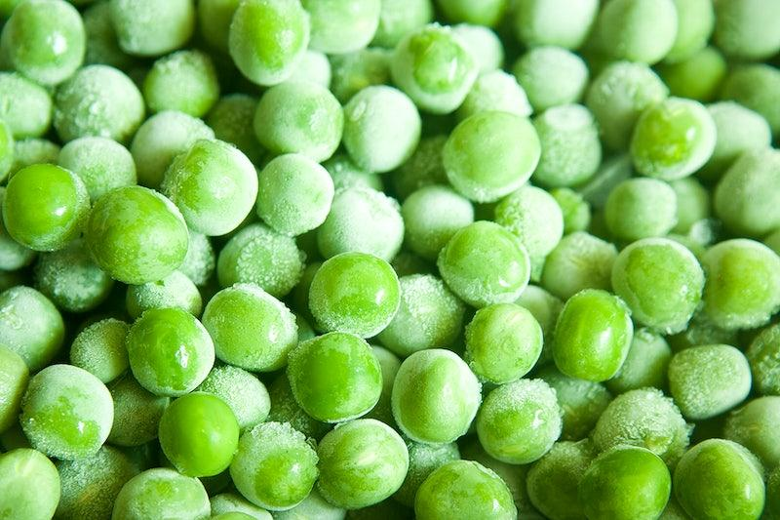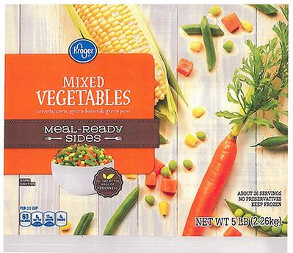

Recipe: Frozen vegetable Fried Rice
Prep time: 10 minutes
Cook time: 15 minutes

Ingredients:

2 tbsp. Vegetable oil
1 tbsp. Fresh ginger, peeled and minced
1 garlic clove, minced
1 ½ cups frozen vegetables (peas, carrots, corn or a combination)
2 cups cooked white or brown rice
1 tbsp. Low sodium soy sauce
Pepper to taste
2 large eggs, beaten

Instructions:

- Heat 1 tablespoon of oil in a large skillet over medium-high heat. Add eggs and stir until scrambled, about 5 minutes. Set aside.
- Heat the rest of the oil in the same skillet. Add ginger, garlic, rice, soy sauce and pepper. Saute for 5 to 10 minutes.
- Add frozen vegetables and saute for another 5 minutes until vegetables are heated through.
- Add scrambled eggs back to the pan and stir everything together until mixed well.
- Serve immediately.

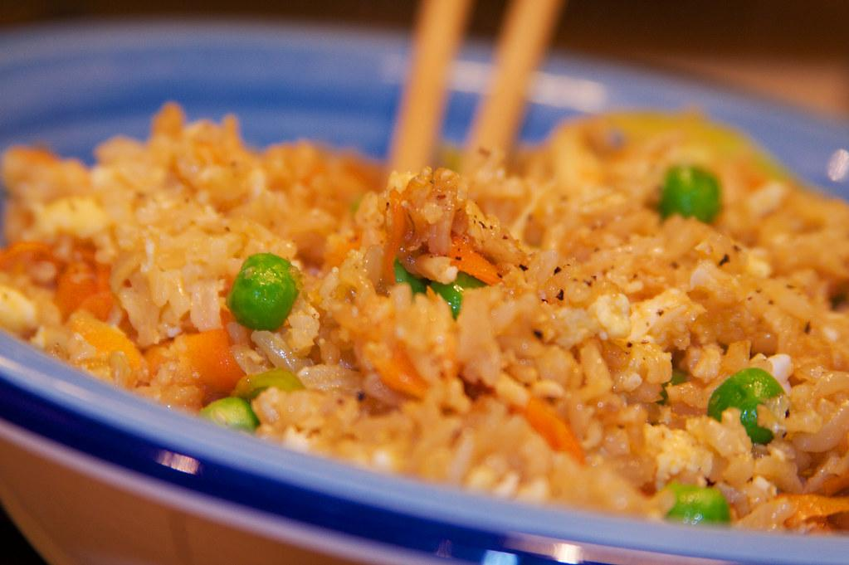

How to cook dry or canned beans

- Beans provide protein, fiber, folate, iron, potassium and magnesium while containing little or no total fat, trans-fat, sodium and cholesterol
- Beans are versatile and can be added to any dish. They take on the flavor of any dish easily.
- Beans are readily available all year round and are very affordable.
- Dry beans need to be soaked overnight before cooking or boiled for 45 minutes to 2 hours before they are ready to eat.
- Canned beans must be rinsed and drained before adding to any dish.

Recipe: Beannaise (White Bean Mayonnaise)

Ingredients:

1 ¾ cups cooked white beans (or one 15 oz can)
2 tbsp. Fresh lemon juice
1 tbsp. White wine vinegar or additional lemon juice
½ tsp. Salt
¼ mustard
⅓ cup extra virgin olive oil
⅓ cup canola or vegetable oil

Instructions:

- Place beans, lemon juice, vinegar, salt and mustard in a blender or food processor. Process until very creamy.
- With the processor still running, slowly drizzle in the oils in a slow and steady stream.
- Continue to process until well blended and completely smooth, stopping to scrape down the sides of the container as needed.
- Chill thoroughly before using.
- Lasts about 7 days in the refrigerator or may be frozen.